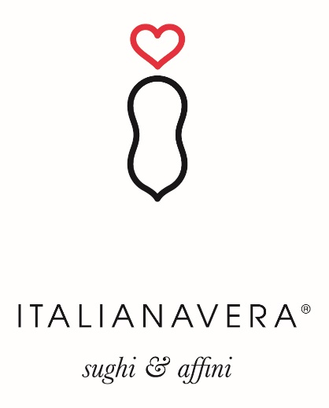

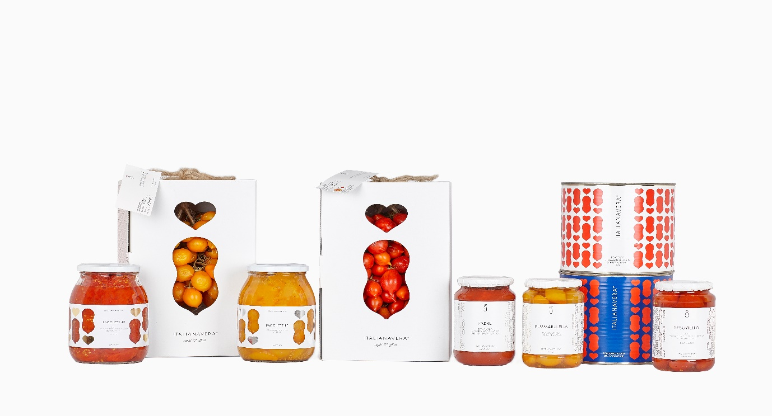

We went looking for a producer of high-quality Corbara tomatoes. We found a treasure. Diana Attianese and her crew, mostly women, at Italianavera (True Italian in English) not only produce Corbari that are among the finest available according to the chefs who vetted them for us, but also a broad selection of other types of tomatoes from the fertile soil around Vesuvius and down the Amalfi coast. Canned, jarred, fresh, packed in juice or acqua, some rare and historic, they provide chefs and retail customers with a selection of product that one of our chefs called “without competition.” They are even willing and able to customize products to meet the special needs of our customers. Take a look at their website at www.italianaverafood.it and you will understand why we are happy to work with Diana bringing her products to the USA.

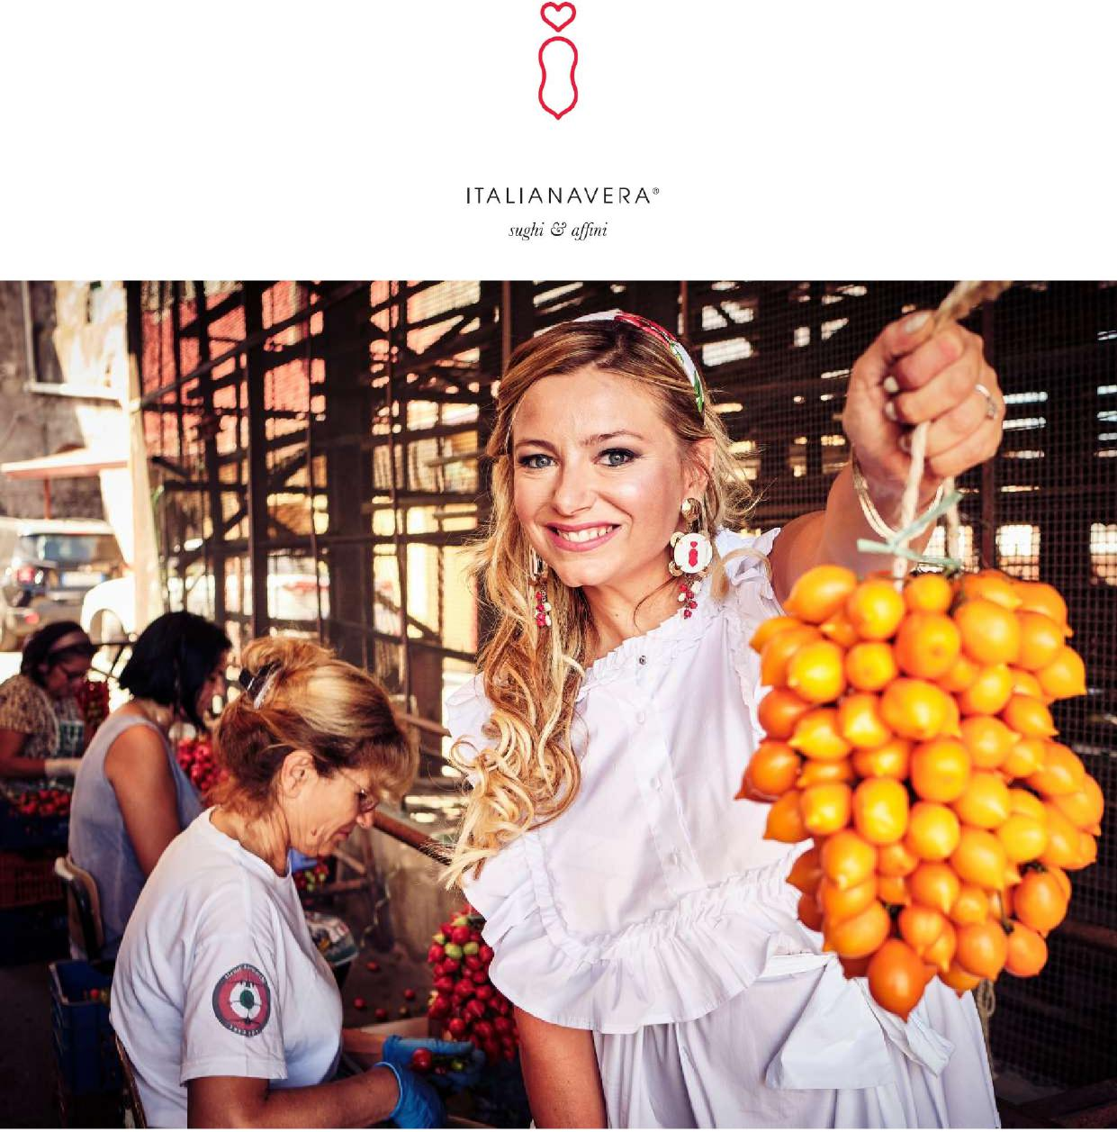
I HAVE A SECRET TO CONFESS:
I believe in the beauty of simple things!
Diana Attianese

ITALIANAVERA

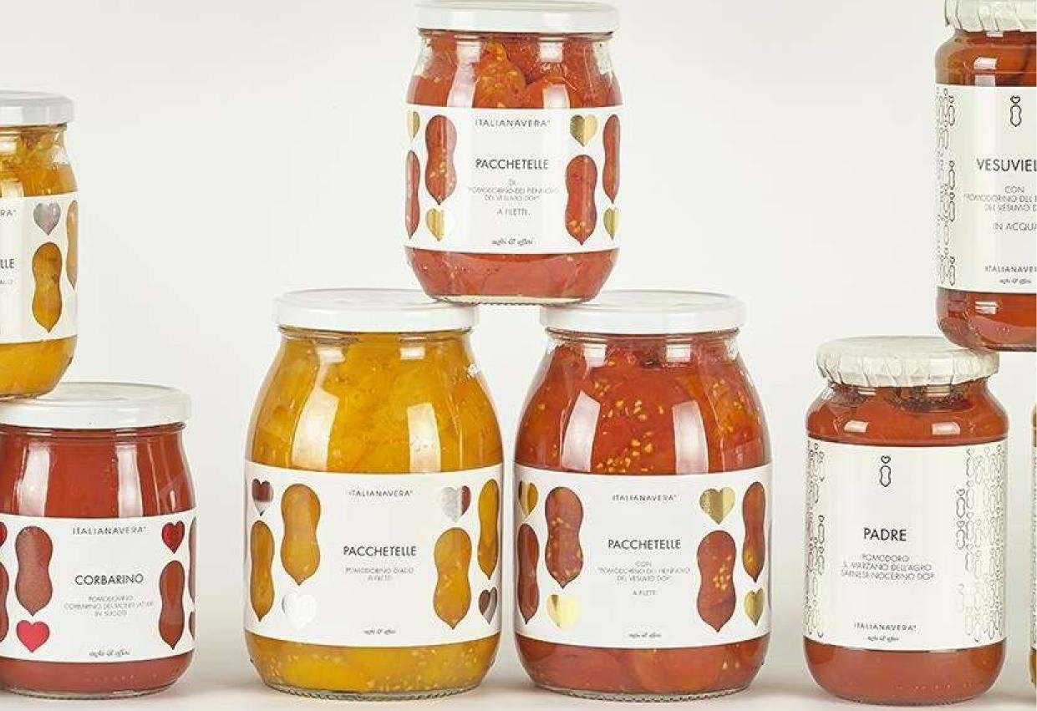
¹⁰⁰⁶C.:-,;•• VAVA'Q
^{Al44}05⁻4-.V•Yr.' • -.
CCIi3Aft.11:40
CCU
I
aCCkli
+'.1..[.1'1-4{I
0
PADRE
h'#Vq ;FA •
PAcC•FITEttE
....IS,. •
A l'ATIL.
= •
klE

OUR VALUES
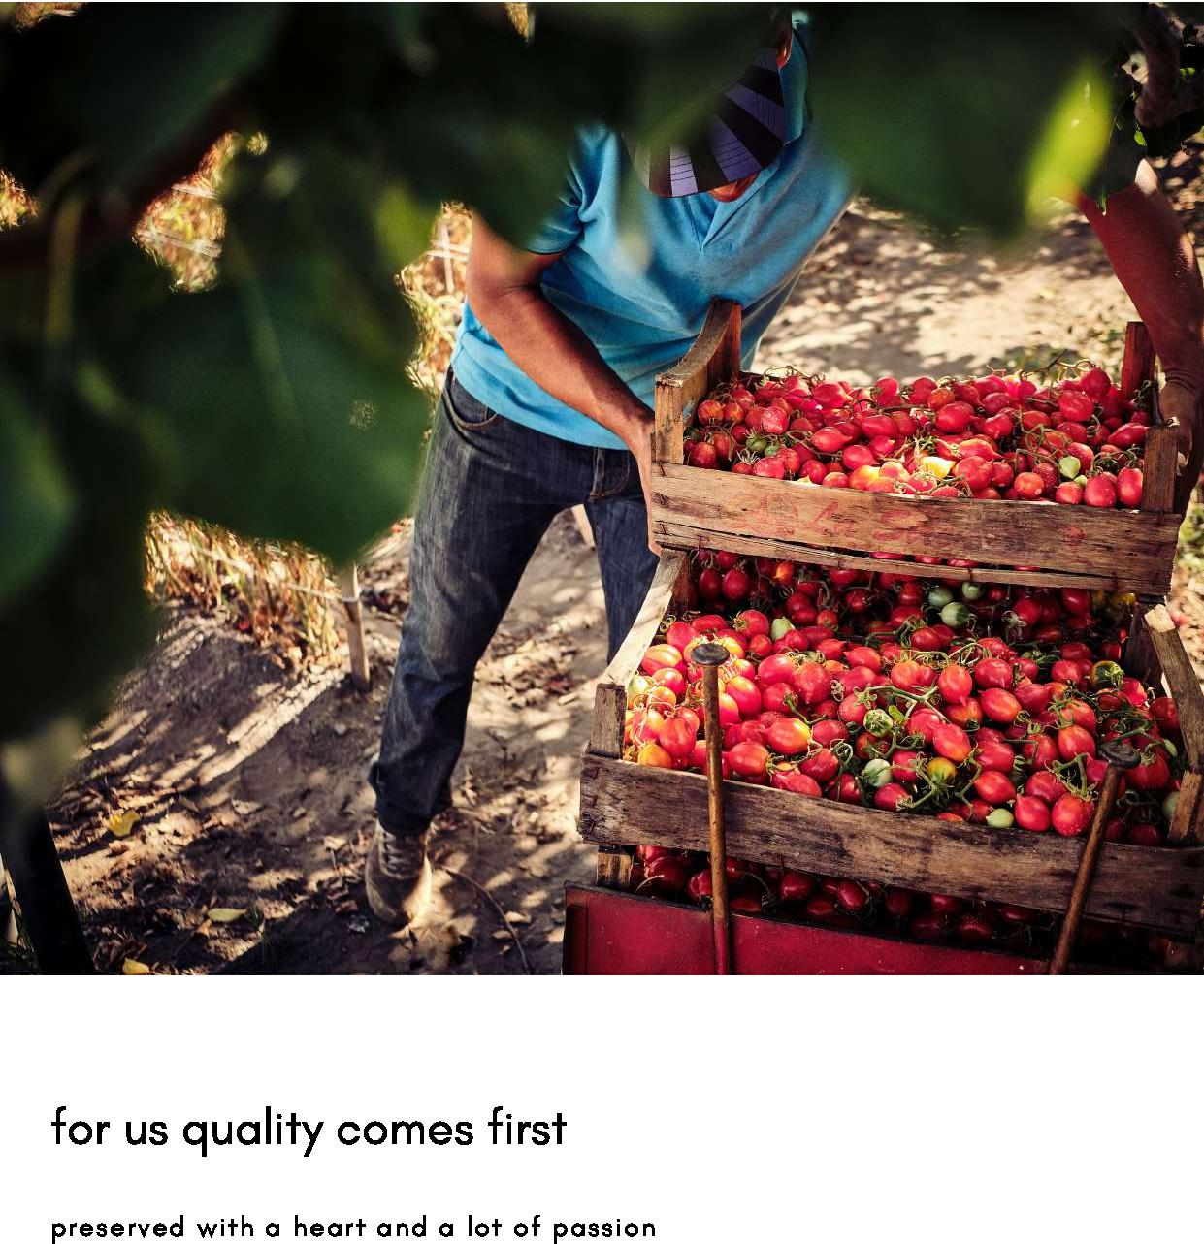

OUR VALUES

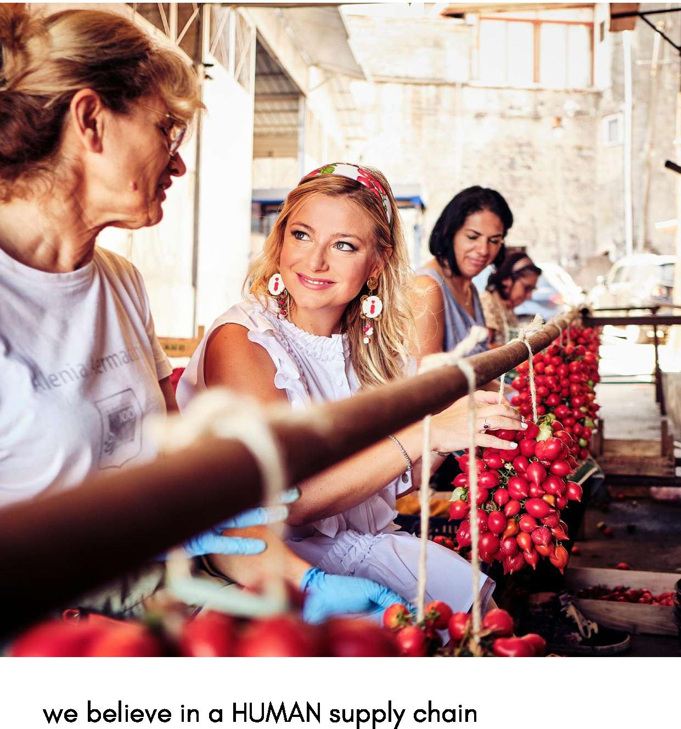

TOMATOES
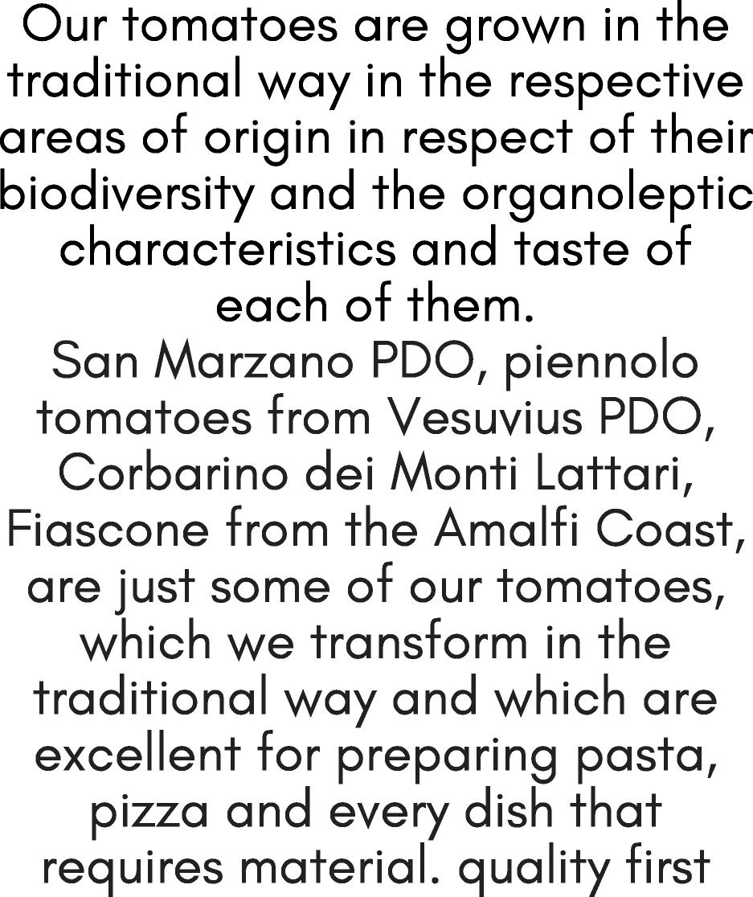

TOMATOES FROM CAMPANIA

CONTROLLED SUPPLY CHAIN,
SELECTED AND HAND
COLLECTED

TRADITIONAL PEELED TOMATO
Obtained from the selection of the best Italian long type tomatoes, processed within a few hours of harvesting and immersed in a soft and delicate sauce that enriches your kitchen preparations with taste
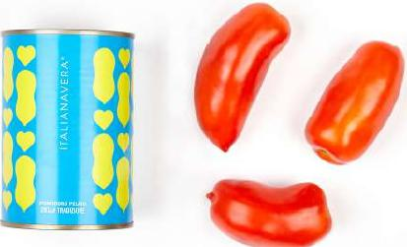
COMMERCIAL INFO:
500 g can contains 400 g of product for 4 or 5 people/ BOX contains 24 pieces - the pallet contains 74 cartons fully enameled can with easy opening, ecofriendly
SPUNZILLO CHERRY TOMATO CULTIVATED ON LATTARI MOUNTINS
The seed of the Vesuvius tomato, pizzutello and in an easy version immersed in its juice, cultivated in the Lattari Mountains is a versatile ingredient that gives all the traditional recipes that intense freshly picked tomato flavor. Excellent to be consumed also raw and on pizzas and bruschetta. COMMERCIAL INFO:
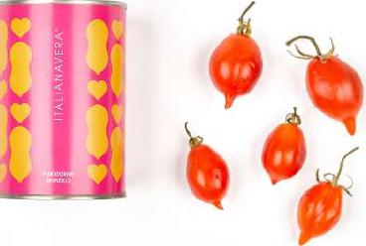
500 g can contains 400 g of product for 4 or 5 people/ BOX contains 24 pieces - the pallet contains 74 cartons fully enameled can with easy opening, ecofriendly

CORBARINO CHERRY TOMATO CULTIVATED ON LATTARI MOUNTAINS
it takes its name from its cultivation area: the hills of Corbara in the province of Salerno.
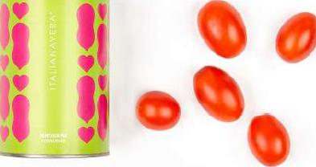
It has an elongated shape and a sweet-sour taste. Ideal for fish dishes or to season pizza in an unusual way.
COMMERCIAL INFO:
500 g can contains 400 g of product for 4 or 5 people. BOX contains 24 pieces - the pallet contains 74 cartons fully enameled can with easy opening, ecofriendly

PDO tomatoes
VESUVIELLO
PUMMARUELLA

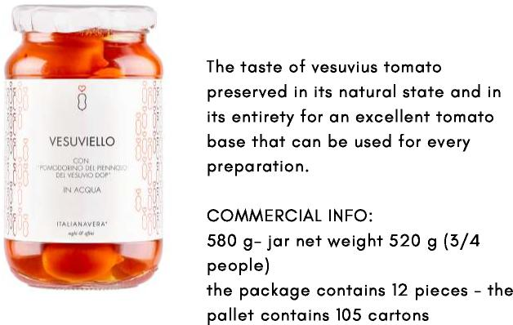
pomodorino del piennolo del Vesuvio DOP in water and salt
PADRE

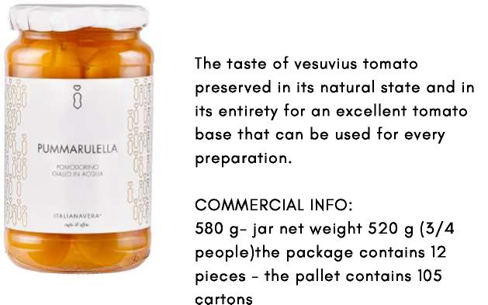
pomodorino del piennolo del Vesuvio giallo in water with salt
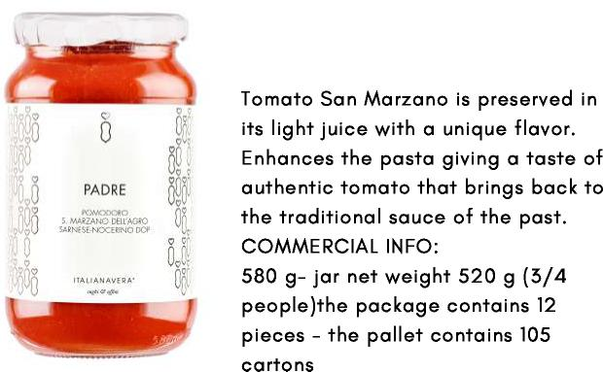
pomodoro SAN MARZANO AGRO SARNESE NOCERINO DOP in San Marzano sauce

le Pacchetelle del Vesuvio

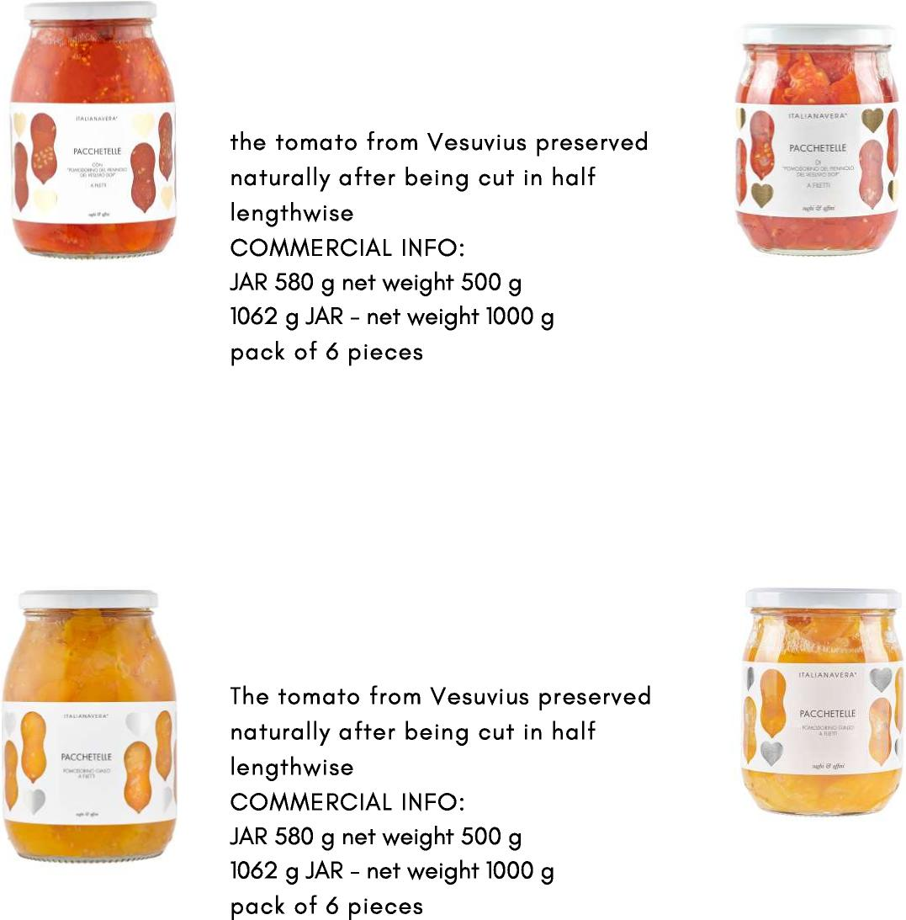
PACCHETELLE
pomodorino del piennolo del Vesuvio DOP sliced
pomodorino del piennolo del Vesuvio giallo SLICED YELLOW TOMATOES
PACCHETELLE

The little tomato called
Corbarino dei Monti Lattari

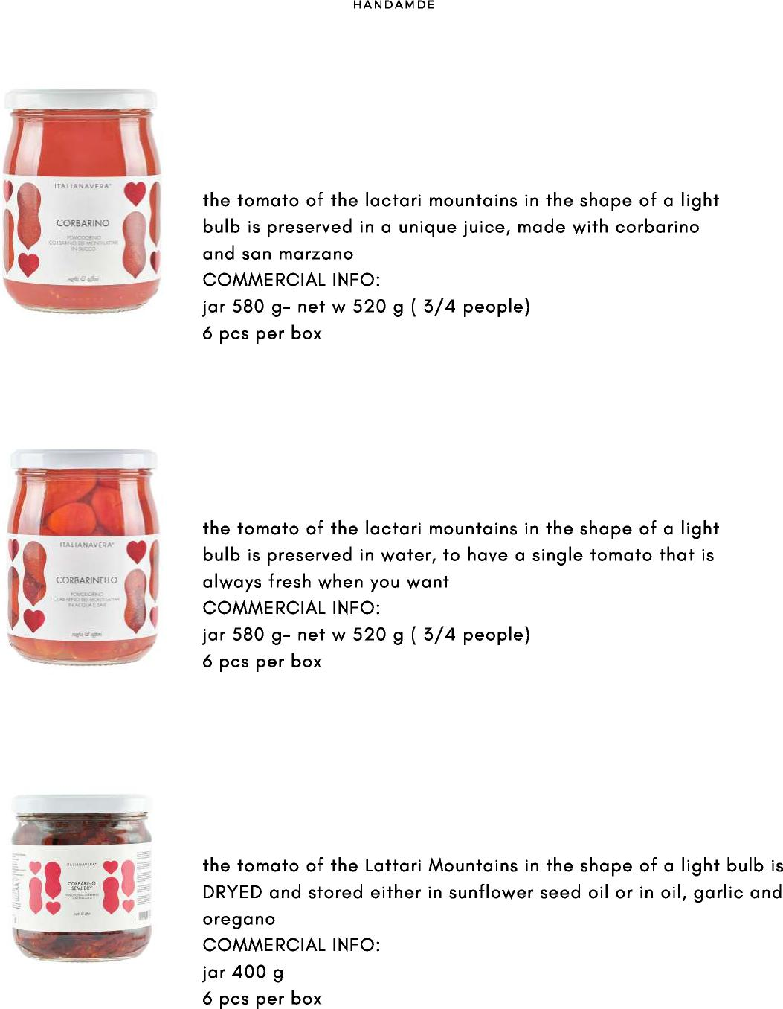
C O R B A R I N O I N S U C C O
pomodorino corbarino dei Monti lattari in succo blend di corbarino e san marzano
C O R B A R I N O I N A C Q U A
pomodorino corbarino dei Monti lattari conservato al naturale in acqua e sale
C O R B A R I N O SEMIDRY
pomodorino corbarino dei Monti lattari SEMISECCO

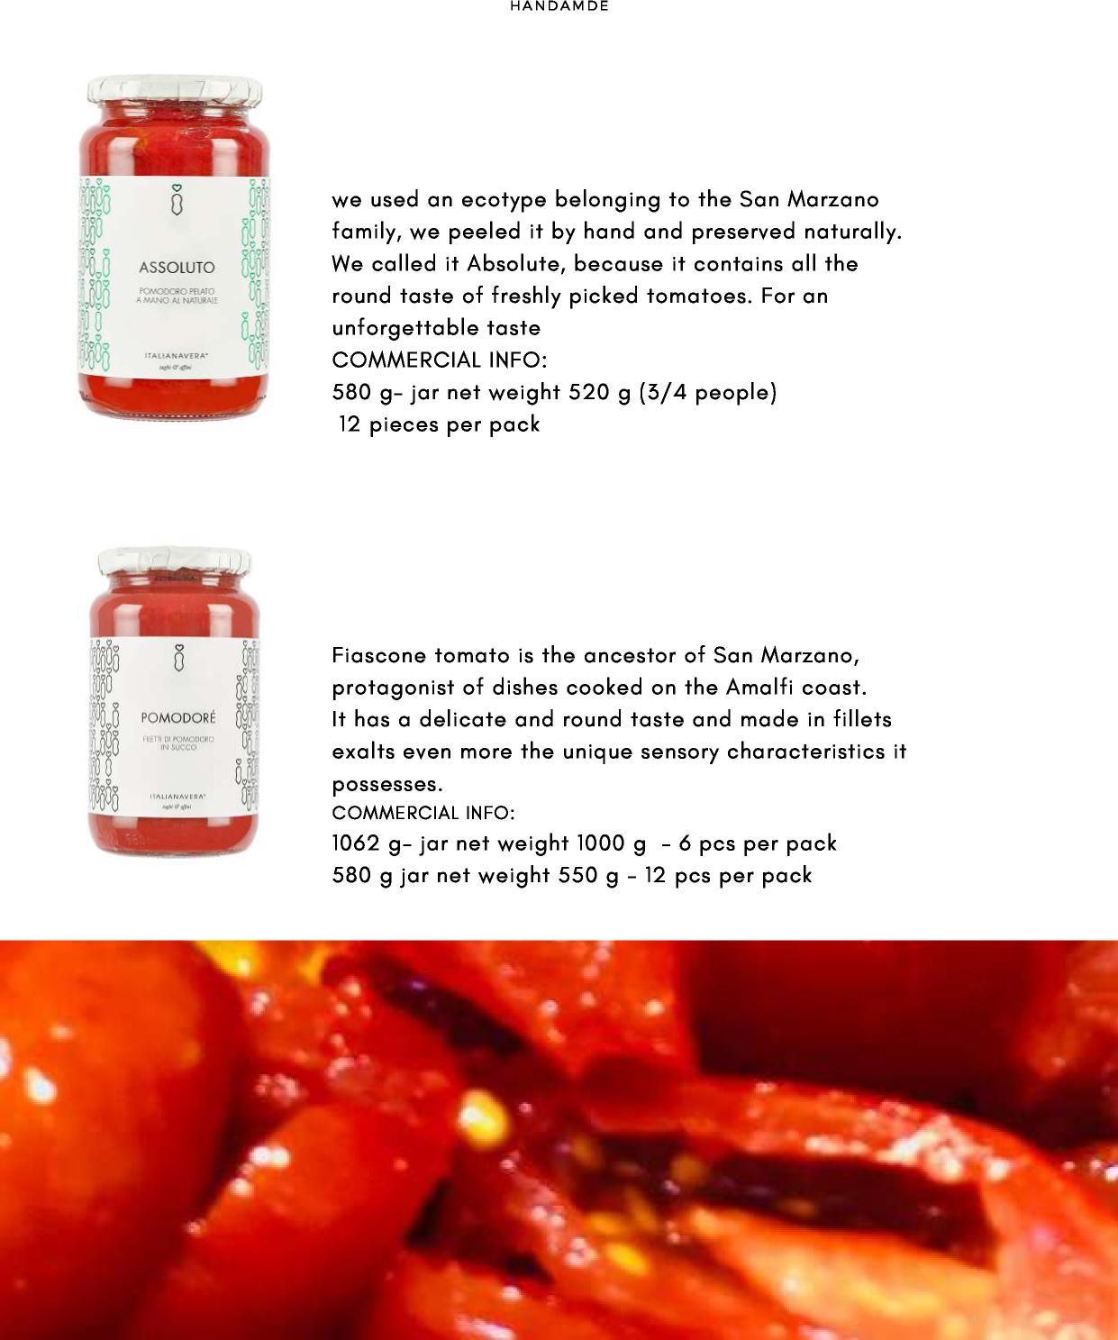
A S S O L U T O D I P O M O D O R O
pomodoro pelato a mano intero al Naturale / natural whole peeled tomato
P O M O D O R E '
filetti di pomodoro Fiascone della costa d'Amalfi in succo di pomodoro Fiascone tomato fillets from the Amalfi coast in tomato juice
il pomodoro Fiascone
della Costa d'Amalfi

il pomodorino del Piennolo
del Vesuvio Fresh

pomodorino del piennolo del Vesuvio DOP E DEL VESUVIO GIALLI A GRAPPOLI
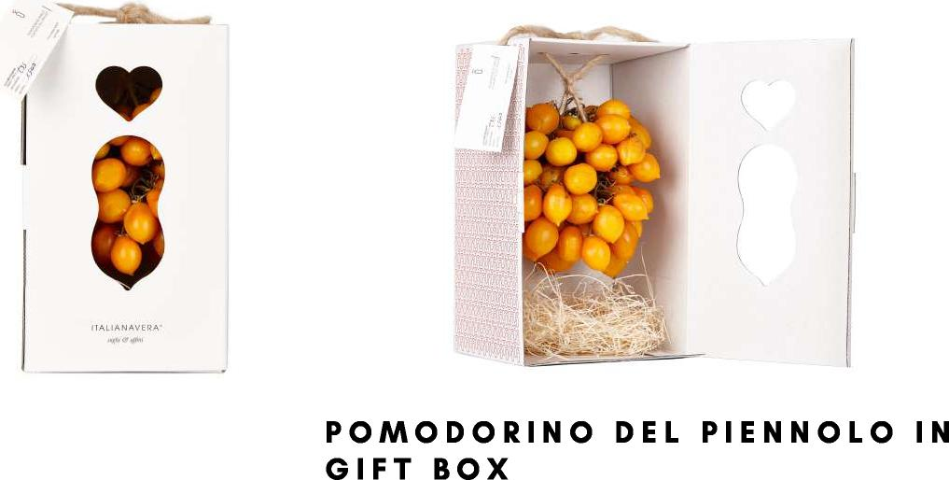

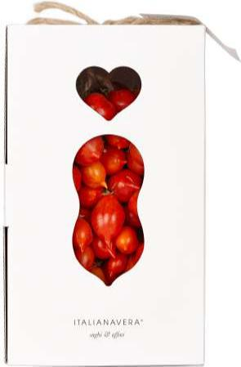 | available in this sizes: 1,5 KG- 2, KG - 2,5 KG  shipped and stored at room temperature, they can be stored until January
 | 